Media Contact: FOR IMMEDIATE RELEASE
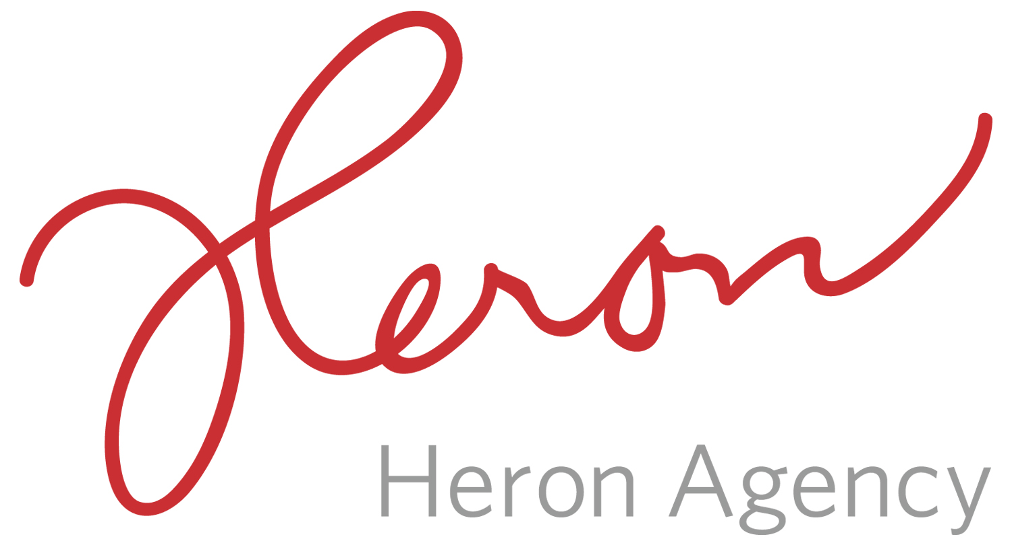
Noreen Heron/Sarah Ficek/Megan Gasper
noreen@heronagency.com
sarah@heronagency.com
megan@heronagency.com
773.969.5200

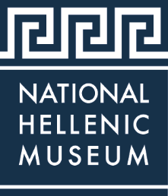

THE NATIONAL HELLENIC MUSEUM ANNOUNCES SONG OF ARGYRIS SCREENING TO COMMEMORATE 75TH ANNIVERSARY OF DISTOMO HOLOCAUST
The National Hellenic Museum Partners with the Patriotic Society of Distomo for Event

CHICAGO (May 2019) – The National Hellenic Museum (NHM), 333 S. Halsted St., will host a screening of the documentary “Song of Argyris” on June 9, 2019, at 1:00 pm, in commemoration of the 75th anniversary of the Distomo Holocaust. The NHM welcomes members of the Patriotic Society of Distomo and the public to attend the film, which follows the story of Argyris Sfountouris, who was four years old in 1944 when German forces murdered 218 villagers in Distomo, including his parents and 30 more relatives. The movie by filmmaker Stefan Haupt, which is in German and Greek, will have English subtitles.

The Patriotic Society of Distomo will also provide photographs and other supplementary information to view prior to the screening. Refreshments will be served.

Admission to the public program is as follows: Non-Members: $15, NHM Members: $10, Students: $5.

###

About the National Hellenic Museum

The National Hellenic Museum (NHM) portrays and celebrates Greek history and the Hellenic legacy through educational classes, exhibits and programs. With a growing repository of over 20,000 artifacts, the Museum catalogs and highlights the contributions of Greeks and Greek Americans to the American mosaic and inspires curiosity about visitors’ own family journeys through cultural expression, oral history and experiential education. Located in Chicago’s Greektown, the NHM provides lifelong learning for the whole community using artifacts and stories to spark inquiry and discussion about the broader issues in our lives.

For more information, visit http://www.nationalhellenicmuseum.org or call 312-655-1234. Follow NHM on Facebook, Instagram, and Twitter.

