Media Contact: FOR IMMEDIATE RELEASE
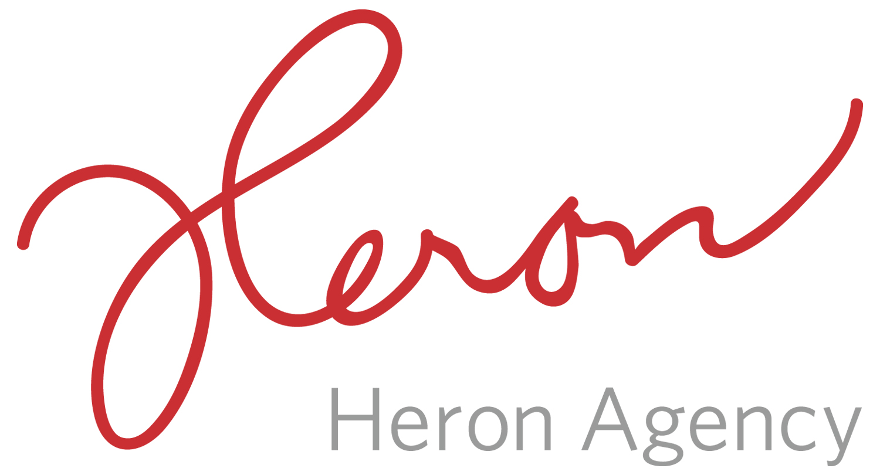
Noreen Heron/Sarah Ficek/Megan Gasper
noreen@heronagency.com
sarah@heronagency.com
megan@heronagency.com
773.969.5200

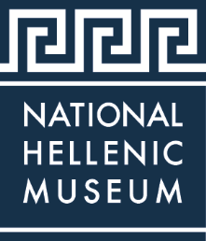

THE NATIONAL HELLENIC MUSEUM TO HOST CONVERSATION ABOUT CURRENT STATE OF REFUGEE CRISIS IN GREECE
The National Hellenic Museum Partners with MedGlobal for Event

CHICAGO (July 2019) – The National Hellenic Museum (NHM), 333 S. Halsted St., will host a conversation with MedGlobal Doctors John Kahler and Peter Houck on the current state of the refugee crisis in Greece on Sunday, August 11, 2019, from 2 - 4 PM. This program is in conjunction with the ongoing exhibition “Lives Afloat: The Greek Refugee Crisis Through the Lens of Tasos Markou 2015-2017” on view at the NHM.
MedGlobal has been at the Moria Refugee Camp since November of 2018. Moria is the largest refugee camp on the Greek Islands, located in southeast Lesvos. There are currently about 6,000 people in a facility built to hold 3,000. In conjunction with a sister NGO, Kitrinos Healthcare, the MedGlobal clinic is there to serve the acute care needs of the camp residents. Their work includes attending to acute psycho-emotional needs as well as addressing medical needs such as respiratory and gastrointestinal illnesses. Dr. Kahler along with Dr. Houck established MedGlobal’s presence at Camp Moria.
Dr. Kahler is a retired board-certified pediatrician who is currently the Chairman of the Board for MedGlobal as well as one of the organization’s cofounders. He has worked in the humanitarian space for 25 years and has been on medical missions throughout the world.
Dr. Houck is a physician from Seattle, WA who has had a long, active career in the medical care of refugees. He spent 28 years as an officer in the United States Public Health Service. He is currently a senior aviation medical examiner for the Federal Aviation Administration, the coordinator for MedGlobal’s Greek operations, and a consultant in public health for civil aviation.
Admission to the public program is as follows: Non-Members: $15, NHM Members: $10, Students: $5.
###
About the National Hellenic Museum
The National Hellenic Museum (NHM) preserves, portrays and celebrates Greek history and the Hellenic legacy through educational classes, exhibits and programs. With a growing repository of over 20,000 artifacts, the Museum catalogs and highlights the contributions of Greeks and Greek Americans to the American mosaic and inspires curiosity about visitors’ own family journeys through cultural expression, oral history and experiential education. Located in Chicago’s Greektown, the NHM provides lifelong learning for the whole community using artifacts and stories to spark inquiry and discussion about the broader issues in our lives.
For more information, visit http://www.nationalhellenicmuseum.org or call 312-655-1234. Follow NHM on Facebook, Instagram, and Twitter.

