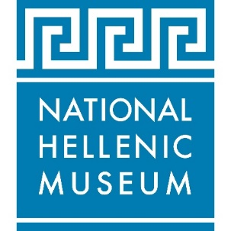
FOR IMMEDIATE RELEASE Press contact: PR Consultant Elizabeth Neukirch
Press images available HERE >> elizabethneukirchpr@gmail.com / 815.751.5844

National Hellenic Museum announces 2022 Gala
Saturday, September 10

An evening of fine dining, music, dancing, a spectacular auction and
special live performance from singer Thanos Petrelis

CHICAGO (August 2022)—The National Hellenic Museum (NHM), a premier museum dedicated to sharing Greek history, art, culture and the Greek American story, announces its annual Gala on Saturday, September 10 at 6 p.m. at the Hilton Chicago (720 South Michigan Avenue).

The 2022 NHM Gala is part of the museum’s grand reopening celebration in September, which includes the world premiere of a major new photography exhibition, Resilience by HRH Prince Nikolaos, opening on September 16.

The NHM Gala is an opportunity for hundreds of Greek Americans and philhellenes from across the country to gather together for a night of philanthropy celebrating and supporting the lasting and enriching Hellenic legacy. The festive evening is black tie optional and features a cocktail reception followed by fine dining, a spectacular auction, music and dancing, including a special live performance from popular Greek singer Thanos Petrelis.

The Gala Chairman is John S. Koudounis and the National Hellenic Museum Chairman is John P. Calamos, Sr.

Individual tickets are $375 and tables of ten are $3,400, with additional sponsorship opportunities available. For more information on the 2022 NHM Gala and to RSVP for tickets and sponsorships, visit NationalHellenicMuseum.org/Gala2022.

The National Hellenic Museum is a premier museum dedicated to sharing Greek history, art and culture, from ancient times to the present day, including the modern Greek American experience. Originally founded in 1983 and located in Chicago’s historic Greektown neighborhood since 2011, NHM preserves the Hellenic legacy and makes this rich heritage relevant today through its collections, oral histories, exhibits, educational programs and special events. NHM accepted the first artifact into its collections in 1993, a dowry cedar chest that is currently on display in the museum’s core exhibit, The Greek Story in America. Since then, NHM’s collections have become the largest of their kind in the nation: more than 10,000 physical artifacts, more than 100 archival collections, more than 450 oral history interviews and an extensive reference library with a significant holding of Greek American newspapers.

For more information, visit nationalhellenicmuseum.org.

# # #

