Media Contact: FOR IMMEDIATE RELEASE
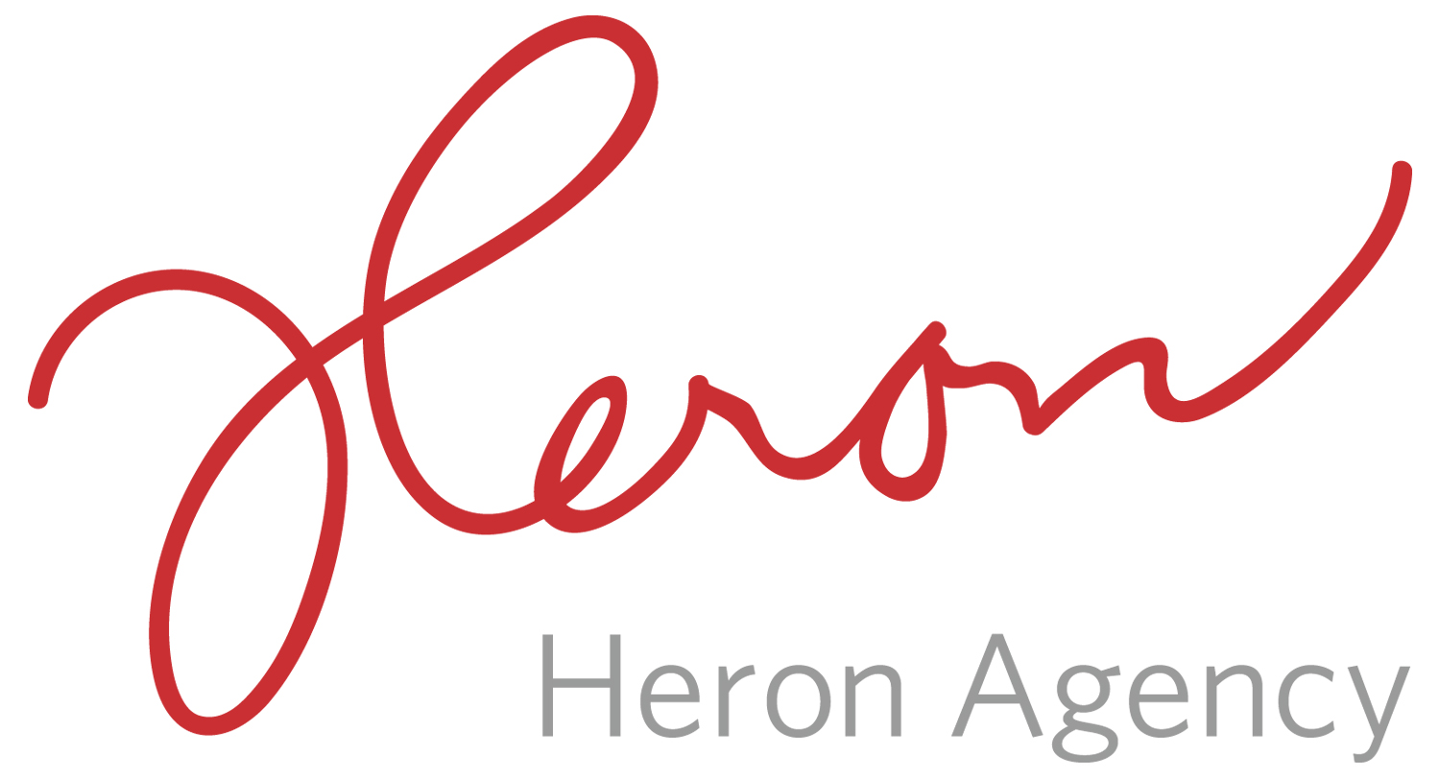
Noreen Heron/Sarah Ficek/Megan Gasper
noreen@heronagency.com
sarah@heronagency.com
megan@heronagency.com
773.969.5200

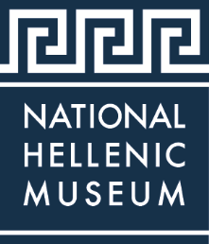

The National Hellenic Museum Marks 35 Years of Honoring Greek American Culture and History
The Museum Gives Life to Chicago’s Cultural Scene with Largest Collection of Greek American Artifacts and Oral Histories with an Array of Programs
CHICAGO (June 2018) – Chicago, rich in its cultural landscape, boasts the National Hellenic Museum (NHM), 333 S. Halsted St., possessing the largest collection of Greek American artifacts and recorded oral histories anywhere in the world. This world class “hidden gem” is dedicated to collecting, preserving and portraying the legacy of Greek history and culture in America. The museum has grown over its 35-year history and features educational classes and programs linking generations of Americans to the Hellenic legacy, a rich repository of 20,000+ artifacts, photos, historic newspapers, books and an impressive archive of 450+ recorded histories.
“We are so grateful to mark our 35th year of educating Chicagoans and visitors, both national and international, about the profound influence of Hellenic ideas,” said Laura Calamos, Ph.D., National Hellenic Museum President. “Our success and the museum’s evolution is truly a culmination of the work of many volunteers, donors and individuals dedicated to our history. In 2017 alone, we were proud to host over 21,000 individuals experiencing field trips, tours and programs. We look forward to continuing to expand our programming and offerings to highlight the importance of understanding the Greek legacy in the context of our modern society.”
The NHM Collections & Archives serve as a central repository for Greek American history. Professional museum staff work to catalog, protect, and preserve the memories and artifacts of the Greek community in the United States. The Museum uniquely specializes in gathering Greek American stories through historically significant objects, archival collections, and oral history recordings, all of which are archived, cared for, and stored at the museum. Archival processes also include cataloging and digitization. Through digitization, the Museum’s ability to support historical, genealogical, and academic research will be greatly enhanced by the NHM as it provides outreach to audiences onsite, offsite, and online.
Dedicated to inspiring both children and adults, the NHM Education team uses a variety of interactive and differentiated teaching methods to promote understanding of history and culture, build lifelong skills, and encourage critical thinking in all ages. The National Hellenic Museum School offers tours, classes, courses, and field trips where anyone can learn about the arts, sciences and humanities as related to Greek history. Expect a thought provoking experience learning from immigration stories that exemplify human ingenuity and the strength of overcoming adversity. Understand the impact of Hellenic ideals in everyday life. See the diverse influence of the Greek diaspora from Homeric times to the present. Offered for pre-K through grade 12, all school programs match Illinois Learning Standards and Common Core Standards. Additionally, the Greek Language Program and docent Guided Tours are all tailored to meet the learning needs of each group and for every age.
Founded in Chicago as the Hellenic Museum and Cultural Center (HMCC) in 1983, the HMCC moved to the city’s Greektown neighborhood in 2004 and opened its current location on Halsted Street as the National Hellenic Museum in 2011. The contemporary four-story building is home to extensive collections, rotating exhibitions, classrooms and a stunning rooftop view of Chicago. Three floors of galleries explore ancient and modern themes and provide multi-use spaces to host tours, public programs, and private events.
Designed by south side-native and Greek American Demetrios Stavrianos, the NHM contains design elements associated with Aristotle such as earth, wind and fire. The symbolic heart of the new building is a dramatic, sky-lit east-to-west-staircase that represents the immigrant experience, cultural ties to Greece and the limitless potential of Greek Americans in the United States. The museum offers a variety of spaces available to rent for weddings and events.
The NHM is open to all ages with admission as follows: adults $10, seniors $8, students $8, and children 3 to 12 years are $7. Children under 3 years of age and members receive free admission. NHM is open Tuesdays, Wednesdays and Fridays from 11 a.m. to 5 p.m., Thursdays from 11 a.m. to 8 p.m., Saturdays and Sundays from 11 a.m. to 5 p.m. and is closed on Mondays. Members enjoy many additional outstanding benefits throughout the year.
NHM counts on member support to help preserve and share the legacy of Hellenism, Greek history and culture through programs, events and exhibitions. To become a member, please visit the Museum’s membership page. For information on the exhibits, programs, membership, special events, facility rentals or giving, please visit www.nationalhellenicmuseum.org.
###
About the National Hellenic Museum
The National Hellenic Museum (NHM) portrays and celebrates Greek history, culture and the impact of Hellenism in America through educational classes, exhibits and programs. With a growing repository of over 20,000 artifacts, the Museum catalogs and highlights the contributions of Greeks and Greek Americans to the American mosaic and inspires curiosity about visitors’ own family journeys through cultural expression, oral history and experiential education. Located in Chicago’s Greektown, the NHM provides lifelong learning for the whole community using artifacts and stories to spark inquiry and discussion about the broader issues in our lives.
For more information, visit http://www.nationalhellenicmuseum.org or call 312-655-1234.Follow NHM on Facebook, Instagram, and Twitter

